Bahria University,

Karachi Campus



LAB EXPERIMENT NO.

8

LIST OF TASKS

|  |  |
| --- | --- |
| TASK NO | OBJECTIVE |
| 1 | Find the shortest path from KZN to ASF weighted by distance with the help of A* algorithm. |
| 2 | Find the shortest path of those flights which have one stop by using A* algorithm weighted by distance. |
| 3 | Fill null values by zero and replace 0 values by ‘N’ in codeshare column. |
|  |  |
|  |  |
|  |  |
|  |  |
|  |  |
|  |  |

Submitted On:

# **Task 1: Find the shortest path from KZN to ASF weighted by distance with the help of A* algorithm.**

**CODE:**



**OUTPUT:**



**Task 2: Find the shortest path of those flights which have one stop by using A* algorithm weighted by distance.**

**CODE**



**OUTPUT**

**Task 3: Fill null values by zero and replace 0 values by ‘N’ in codeshare column.**

**CODE:**

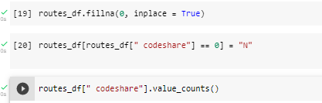

**OUTPUT:**

